**Course Methods Test 1 Year 12**

Student name: ________________ Teacher name: ________________

**Task type: Response**

**Reading time for this test : 5 mins**

**Working time allowed for this task: 40 mins**

**Number of questions: _____6______**

**Materials required:** Upto three calculators/classpads

Standard items: Pens (blue/black preferred), pencils (including coloured), sharpener, correction fluid/tape, eraser, ruler, highlighters

Special items: Drawing instruments, templates, notes on one unfolded sheet of   
A4 paper,

**Marks available: 41 marks**

**Task weighting: 13%**

**Formula sheet provided: no but formulae listed on next page.**

**Note: All part questions worth more than 2 marks require working to obtain full marks.**

Useful formulae

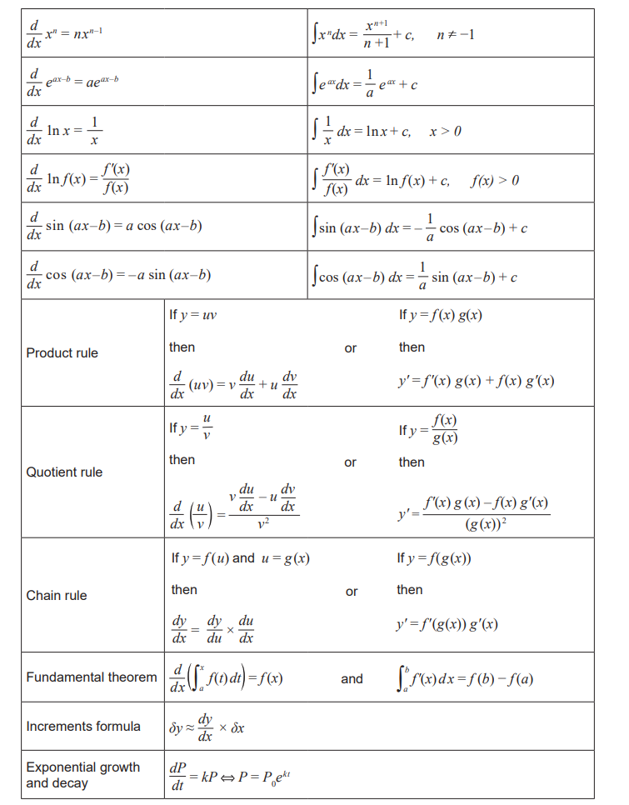Q1 (2, 3, 2 ,2 & 3 =12 marks)

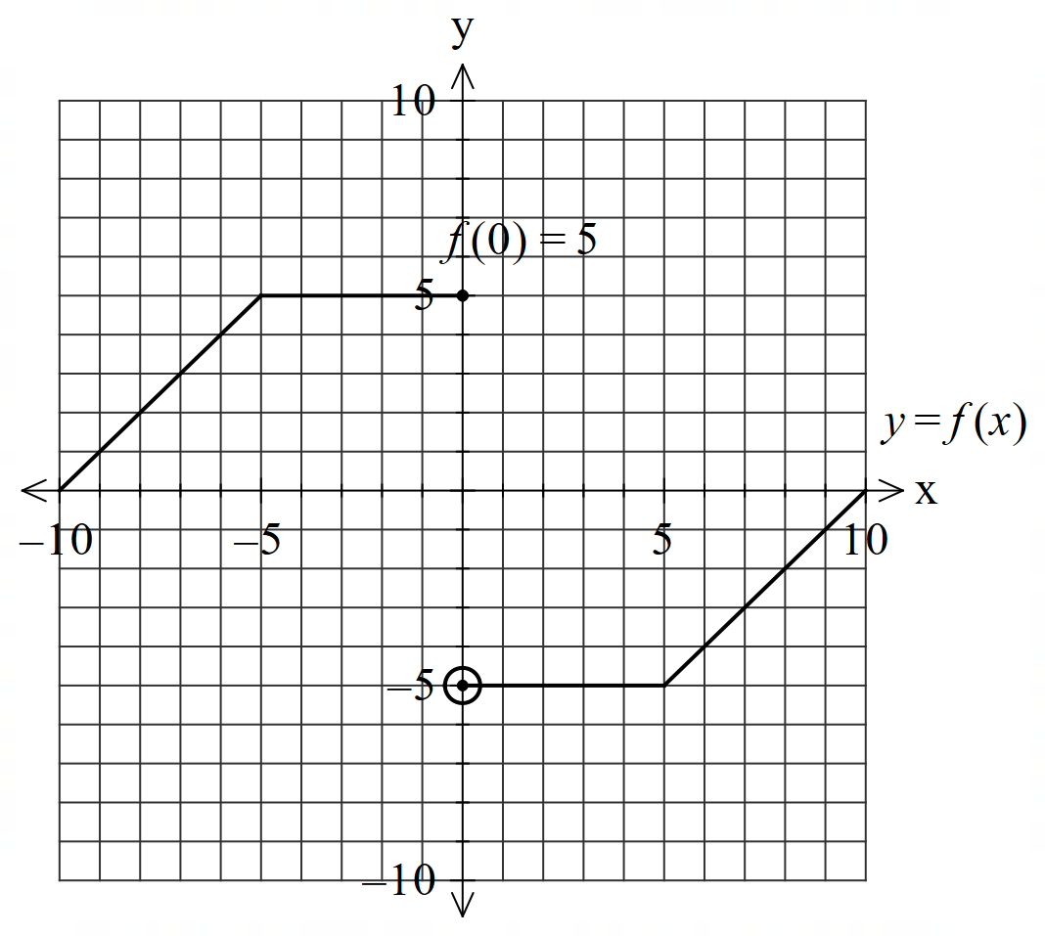Consider the function  which is graphed below.

1. .

|  |
| --- |
| **Solution** |
| Zero as right side is negative of left side |
| **Specific behaviours** |
| P must state zero  P recognises that left = - right |

1. .

|  |
| --- |
| **Solution** |
|  |
| **Specific behaviours** |
| P shows integral under f from x=-3 to x=3 equates to zero  P states antiderivative of 4  P subs x values |

1.  when .

|  |
| --- |
| **Solution** |
|  |
| **Specific behaviours** |
| P uses FTC  P states result |

1. .

|  |
| --- |
| **Solution** |
|  |
| **Specific behaviours** |
| P uses FTC  P states result |

1.  in terms of  for .

|  |
| --- |
| **Solution** |
|  |
| **Specific behaviours** |
| P uses FTC  P uses chain rule  P states explicit result in terms of t only |

Q2 (4 marks)

Sketch a continuous function **showing the  coordinates and labelling** of all special features on the axes below that meet the following requirements.



Has **exactly** two stationary points.

|  |
| --- |
| **Solution** |
|  |
| **Specific behaviours** |
| P labels and shows x coordinates of x & y intercepts  P labels and show approx. x value of inflection pt  P labels and shows x values of both turning pts  P correct shape of curve |

Q3 (3 marks)

Consider a balloon whose volume , litres, varies with time,  seconds, such that .

If the balloon fully deflates after 12 seconds, determine the initial volume. Full reasoning must be shown for full marks.

|  |
| --- |
| **Solution** |
| Initial volume = 3.33 litres |
| **Specific behaviours** |
| P uses a **definite** integral (Must be shown)  P states antiderivative  P states initial volume with UNITS and to at least 2 dp |

Q4 (2, 2 & 3 = 7 marks)

An object’s displacement,  metres at  seconds, from the origin is metres.

1. Determine the velocity function.

|  |
| --- |
| **Solution** |
|  |
| **Specific behaviours** |
| P differentiates  P determines velocity function , no need for units nor simplifying |

1. Determine the first two times that the object changes direction.

|  |
| --- |
| **Solution** |
| Time= 0.52 & 1.15 seconds |
| **Specific behaviours** |
| P equates velocity to zero  P states at least the first two times |

1. Determine the distance travelled in the first 1.5 seconds.

|  |
| --- |
| **Solution** |
| Accept 7.02 to 7.25 due to rounding errors |
| **Specific behaviours** |
| P determines initial position  P determines positions when velocity = 0  P states distance, no need for units & between 7.02 and 7.25  Accept integration of absolute velocity for full marks if stated in full with correct limits  ( Answer only – 2 marks) |

Q5 (2 & 4 = 6 marks)

1. Determine  **without the use of a classpad**. Full reasoning must be given.

|  |
| --- |
| **Solution** |
|  |
| **Specific behaviours** |
| P uses product rule, clearly shown via brackets or defining u & v functions  P at least one term correct  (Note- zero marks if answer given only) |

1. Hence show how to determine  **without the use of a classpad**. Full reasoning must be given **using** the result from part a.

|  |
| --- |
| **Solution** |
|  |
| **Specific behaviours** |
| P shows with **integral signs** that both sides of part a are integrated  P uses FTC  P integrates cosine term  P rearranges to show value of required integral |

Q6 (2, 4 & 3 = 9 marks)

Consider a glass wall with the height metres **above floor** at  metres along the floor according to

 . The glass wall sits on a stone support of height 8 metres.

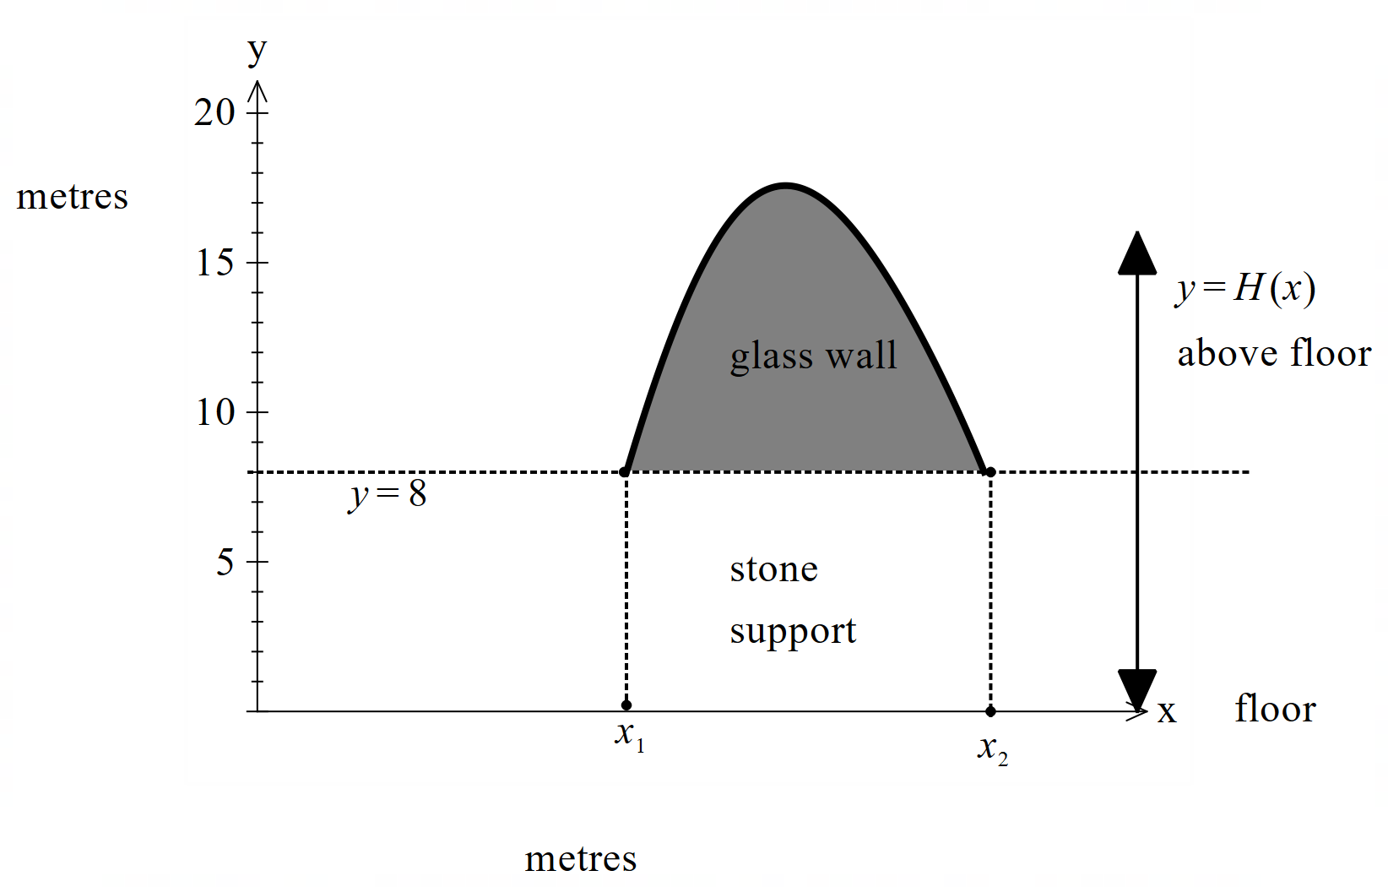

1. Determine the values  to the nearest cm.

|  |
| --- |
| **Solution** |
| |  |  | | --- | --- | |  |  |   X1=3.02metres X2=5.95metres |
| **Specific behaviours** |
| P states both x values  P rounded to nearest cm, 2 dp m or whole cm, no need for units only rounding. |

1. Using calculus, determine the maximum height of the wall. Justify.

|  |
| --- |
| **Solution** |
| Max height = 17.58 metres |
| **Specific behaviours** |
| P states first derivative function  P equates derivative to zero and solves for x  P uses derivative test **with result** to show nature  P states y value of turning point, no need for units |

1. If the wall is 5 cm wide determine the volume of glass with units, needed to make the wall.

|  |
| --- |
| **Solution** |
| Volume = 0.903 cubic metres |
| **Specific behaviours** |
| P sets up definite integral for area  P uses correct limits in definite integral  P changes 5 cm into metres and states volume **with units cubic metres or cubic cm** |

Q6c continue.

End of test.